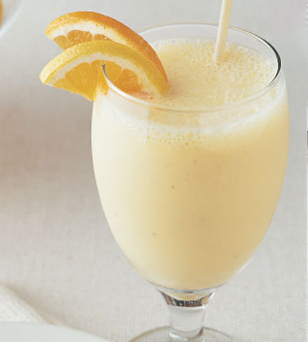

Fruit Yogurt Smoothie

**Healthy,nutritious and refreshing drink.Great for breakfast for energy boost.**

**Recipe IngredientsServes 2.**

* **1 cup plain yogurt**
* **1/4 cup pineapple juice or mixed fruit juice**
* **1 ripe banana**
* **2 tsp honey**
* **2 tsp vanilla**
* **2 tsp peanut butter**

**Recipe Method**

1. **Blend all ingredients on high until smooth.**
2. **If serving cold,add ice cubes one at a time while blending or refrigerate.**
3. **Enjoy:-)**